Chemical Equilibrium

Chemical equilibrium is defined as the dynamic state in which a reversible response is achieved when a direct response and an inverse response occur at the same time.

Concept of Equilibrium
A chemical reaction is the process by which one or more substances (reactants) are converted into one or more different substances (products). The substance is either a chemical element or a compound. When the reactants are completely converted to products at the end of the process, the chemical reaction is complete. A single arrow is typically used to write an irreversible reaction.
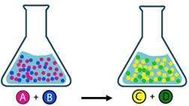

There are many reactions that take place incompletely under the given conditions: the products formed react with each other to restore the original reagent. This is called a reversible reaction. Double arrows are often used to write a reversible reaction, indicating that a simultaneous reaction C and D produces A and B.
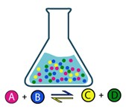

The reaction rate depends on the concentration of the reagent. Initially, the rate of product formation is highest because the amount of reactants is greatest. As the amount of reagent decreases, the conversion rate of the reagent also decreases and the product formation rate increases. After a certain amount of time, the concentrations of the reagents and products become constant, and this state is called equilibrium. It is important to note that the reaction never stops in the equilibrium phase, but the forward and reverse reactions occur at the same time and at the same rate. As a result, the concentration of the substance does not change. An example of a reversible reaction is the formation of nitric dioxide NO2 from nitric oxide N2O4 (gas phase, g).
We can provide graphs of NO2 and N2O4 concentrations over time for this process, as shown in the graph below.
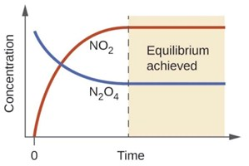

Equilibrium Constant

Based on the concentrations of all other reactive species in equilibrium, a quantity called the equilibrium constant Keq or Kc can be determined.
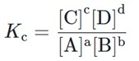
For this reaction , the subscript c stands for "concentration." This is because the equilibrium constant describes the molar concentration in mol/L at equilibrium for a given temperature. Equilibrium constants can help you understand if a reaction tends to have higher concentrations of products or reactants at equilibrium. It can also be used to check if a reaction is already in equilibrium.

Homogeneous and heterogeneous equilibrium

In equilibrium, when all the chemical particles are in the same phase, it is said to be in homogeneous equilibrium. In the case of a solution, they are all dissolved, and in the case of gas equilibrium, they are all gases. However, we can also talk about equilibria where not all species are at the same level. This equilibrium is called a heterogeneous equilibrium.

Le Châtelier's principle

When a chemical reaction is in equilibrium and a change in pressure, temperature, or concentration of a product or reactant occurs, the equilibrium shifts in the opposite direction to compensate for this change. Equilibrium depends on temperature, pressure or concentration. This means that a change in one or more of these parameters stimulates a response that partially compensates for the change while a new equilibrium is established. This is the principle of Le Chatelier.

